**Assignment 5: How to create Dashboards, Metrics, Alarms, SNS topics. Please provide the steps with screenshot**

Create SNS Topic:

Name: Assign5

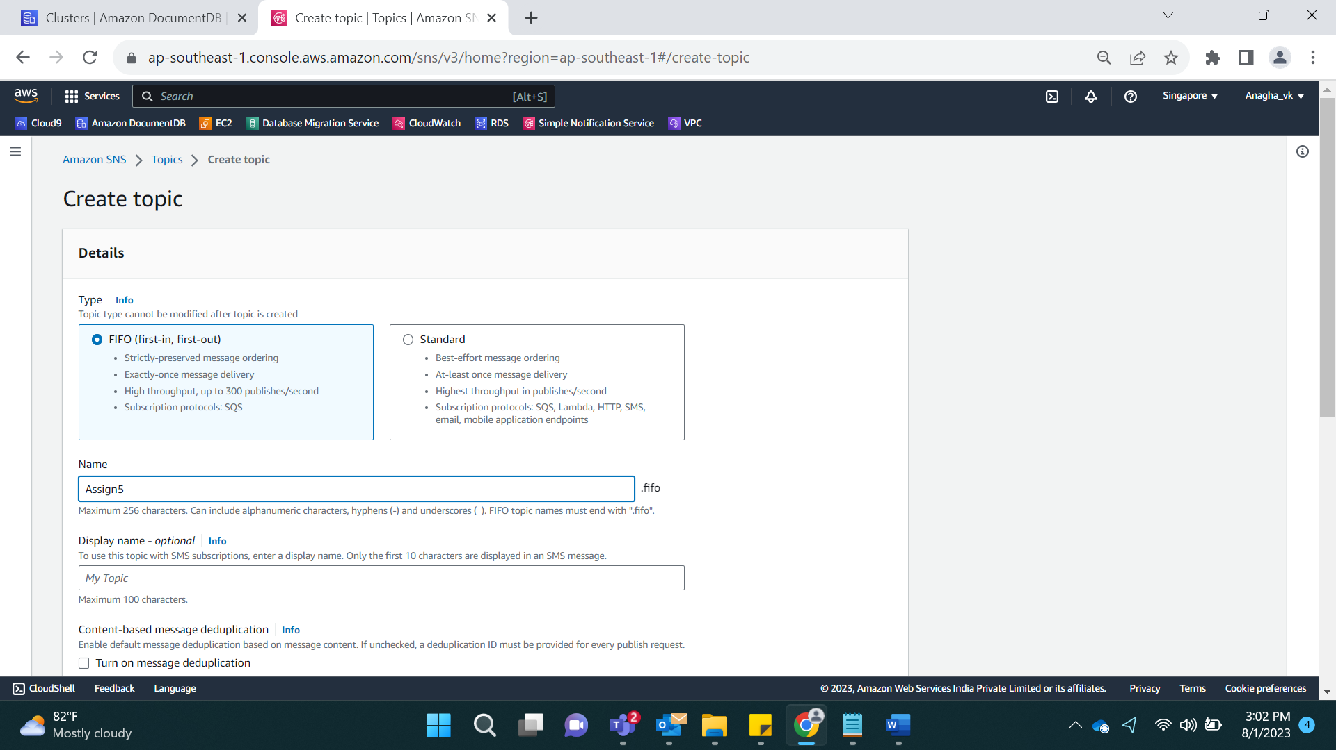

Select Standard

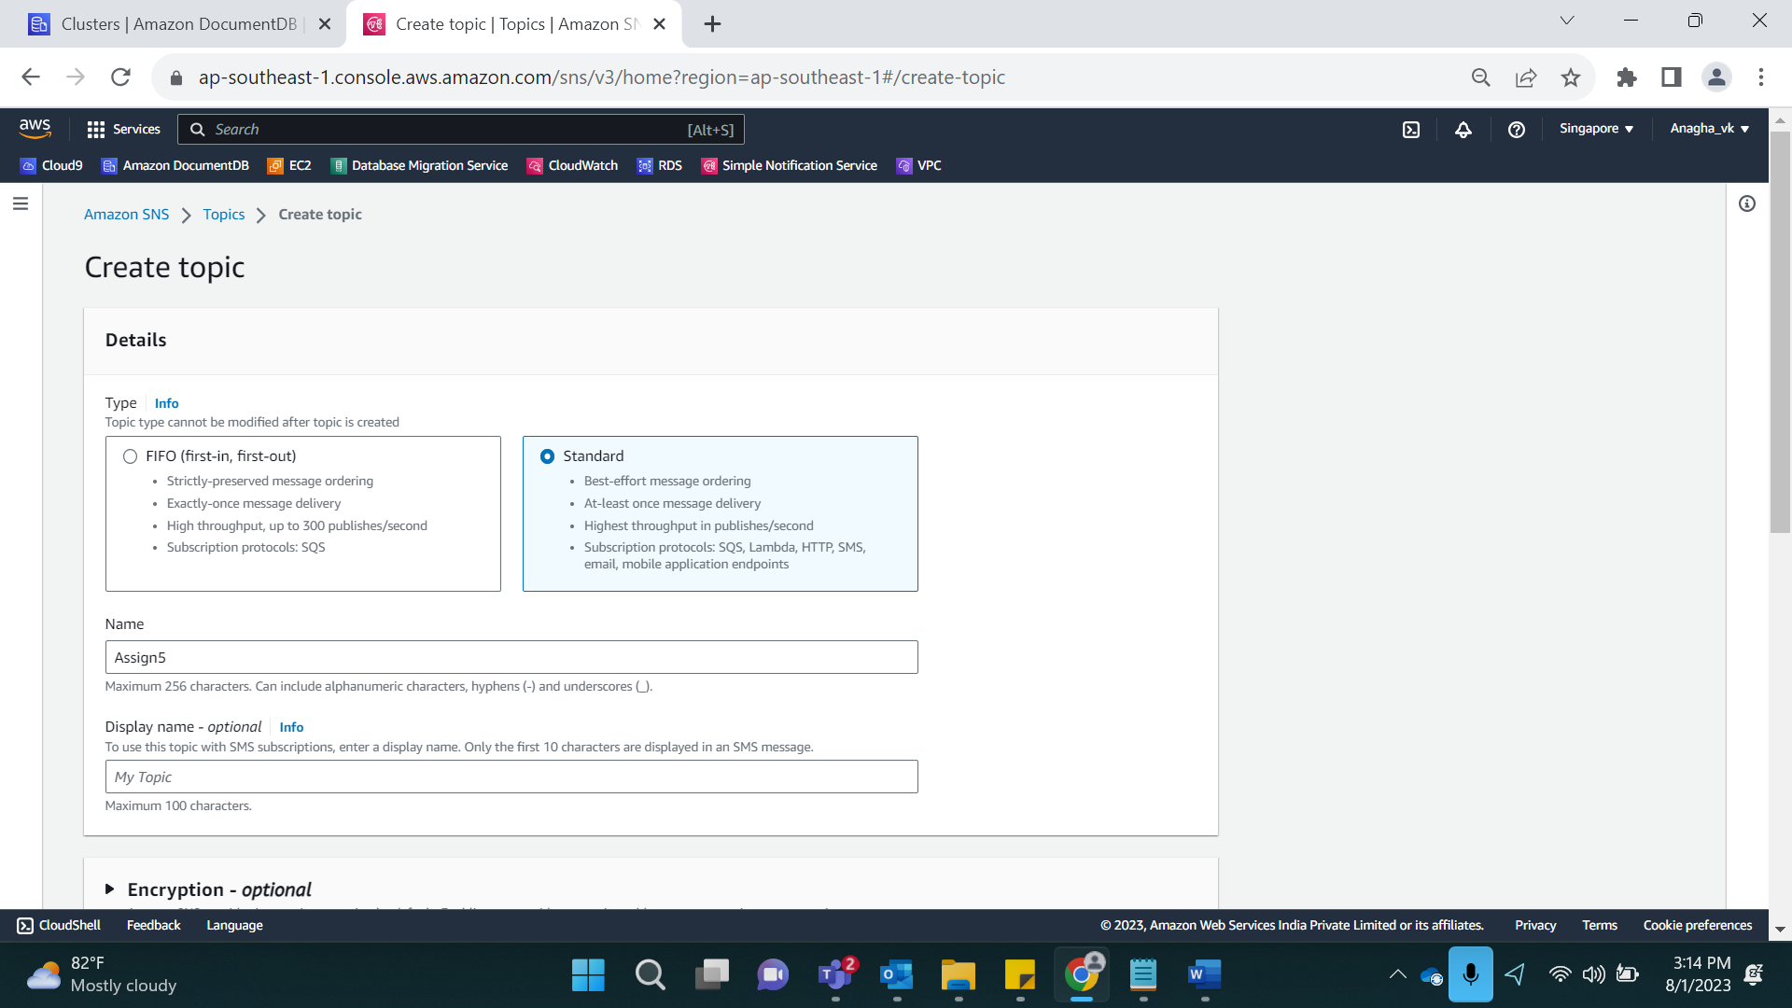

Protocol: Select Email and enter the email ID

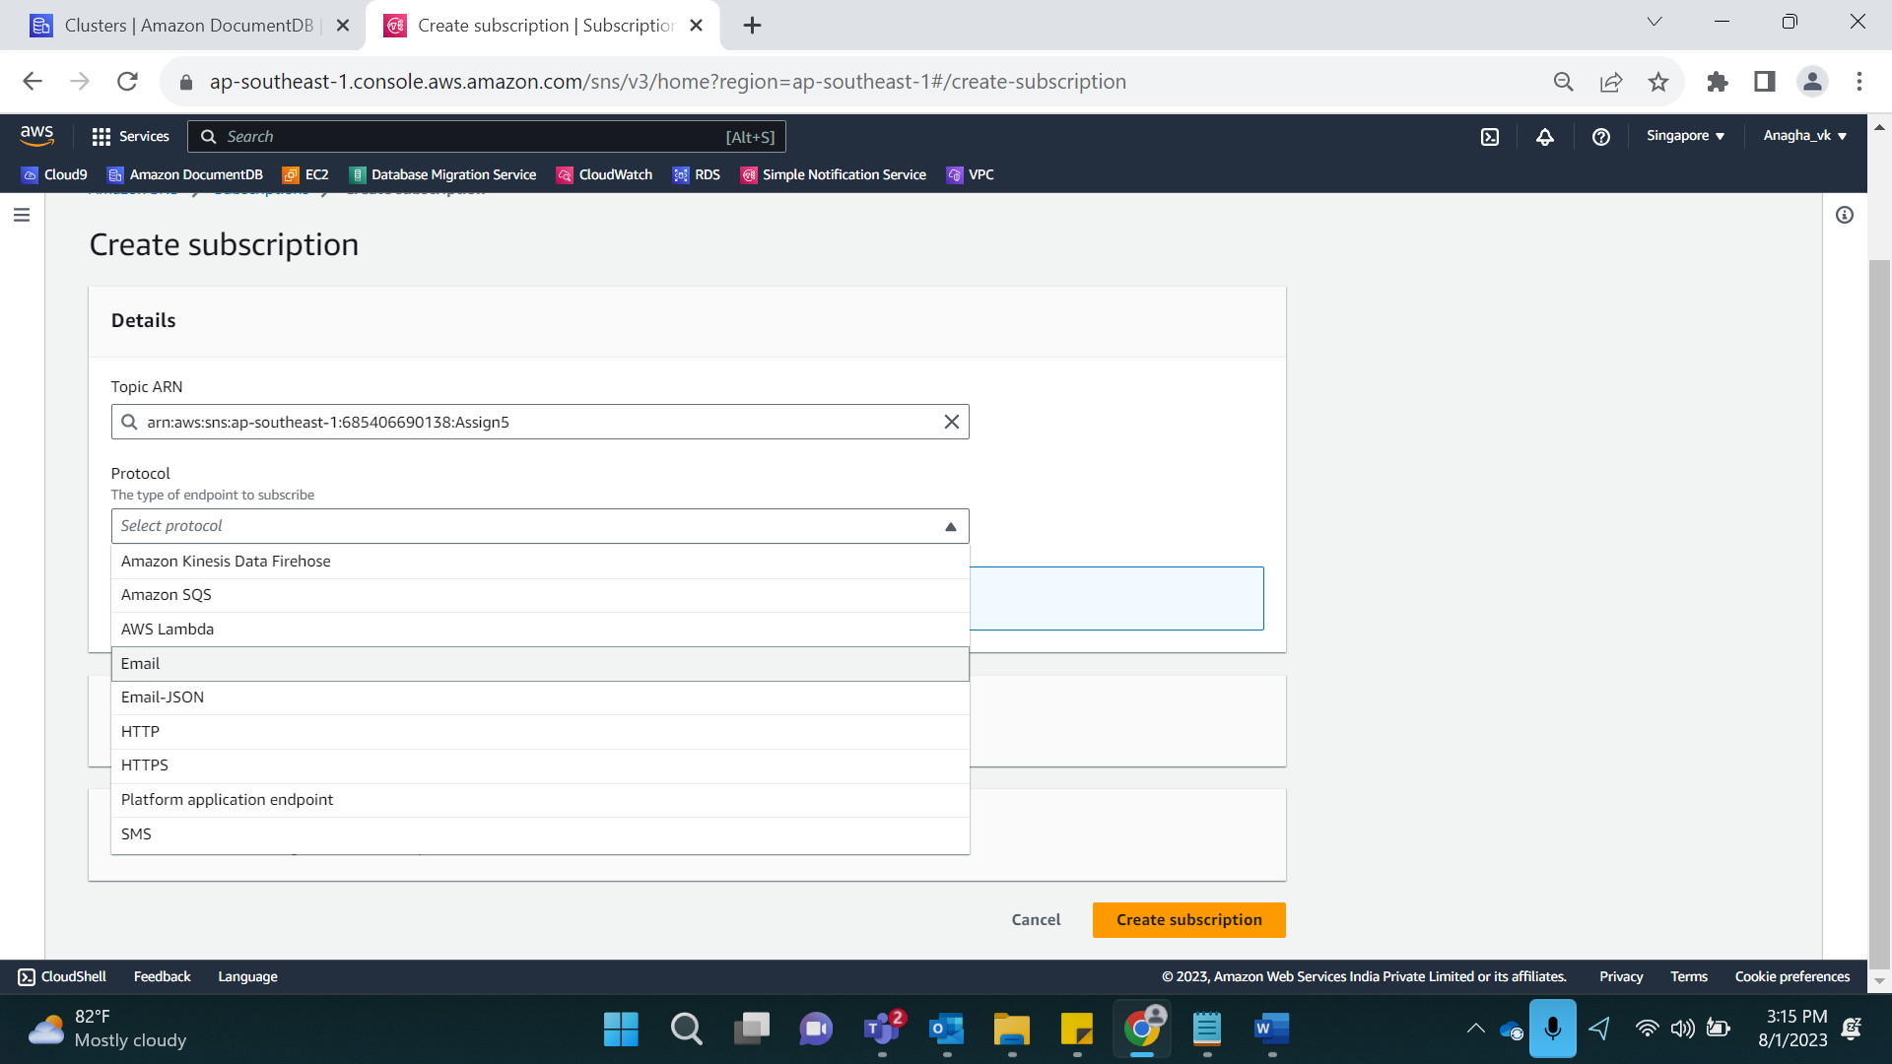

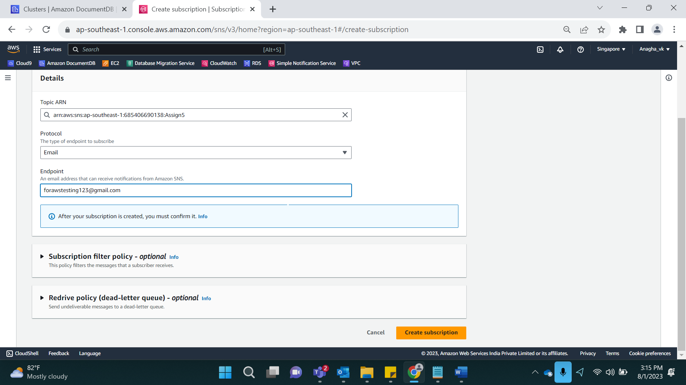

Result:

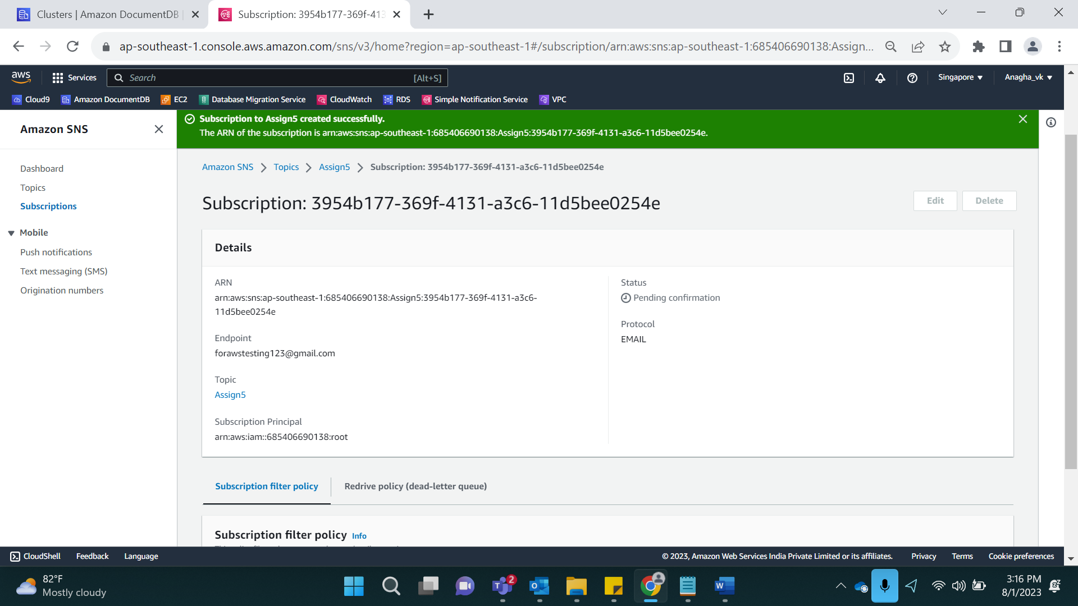

Verify Account:

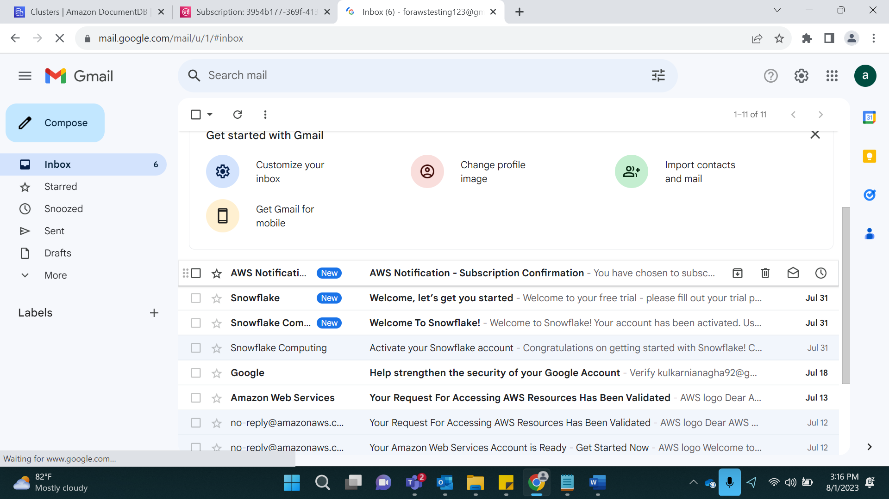

Click on confirm Subscription:

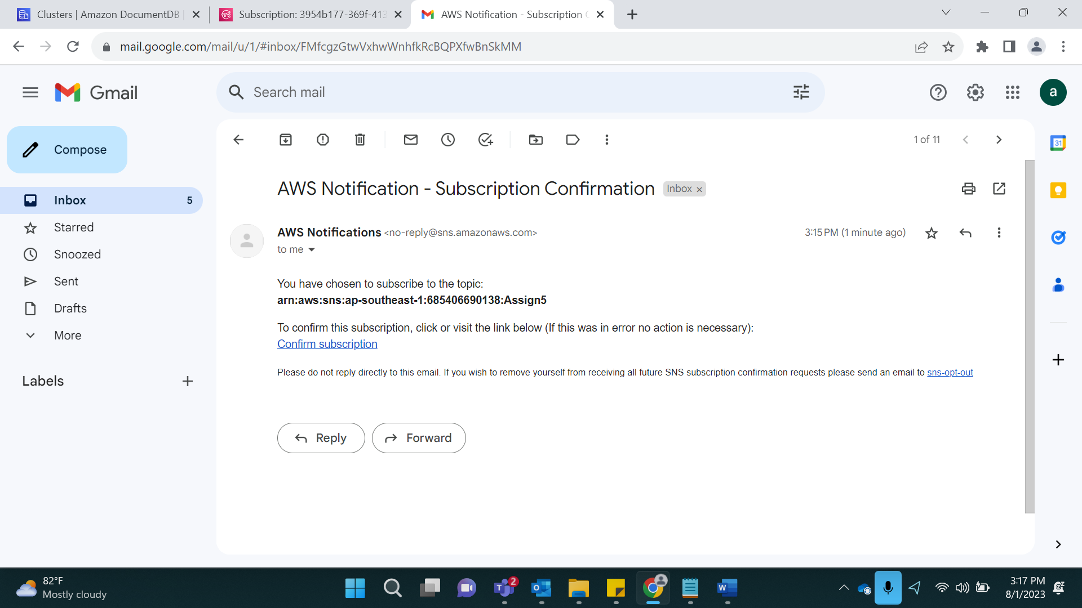

Result:

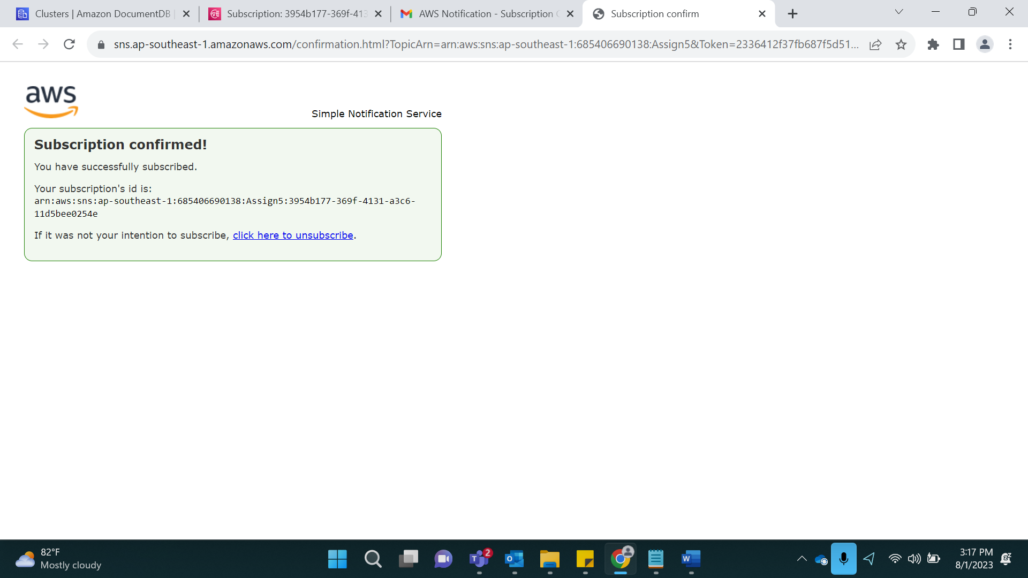

Create alarm in CloudWatch:

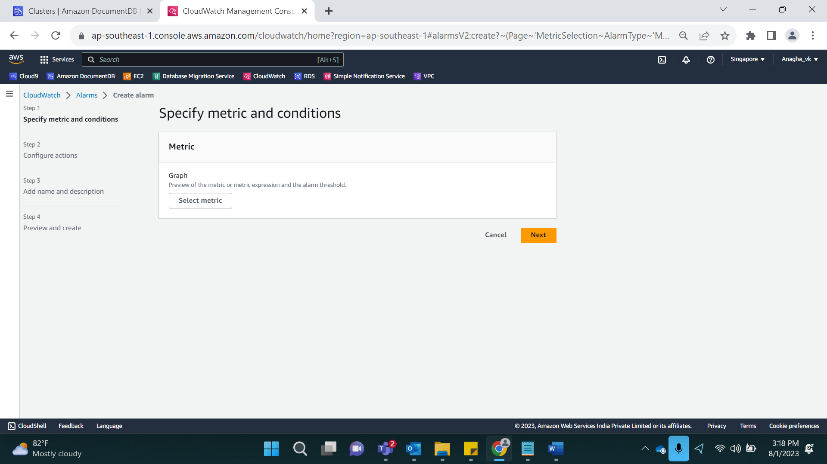

Select DocDB->Cluster

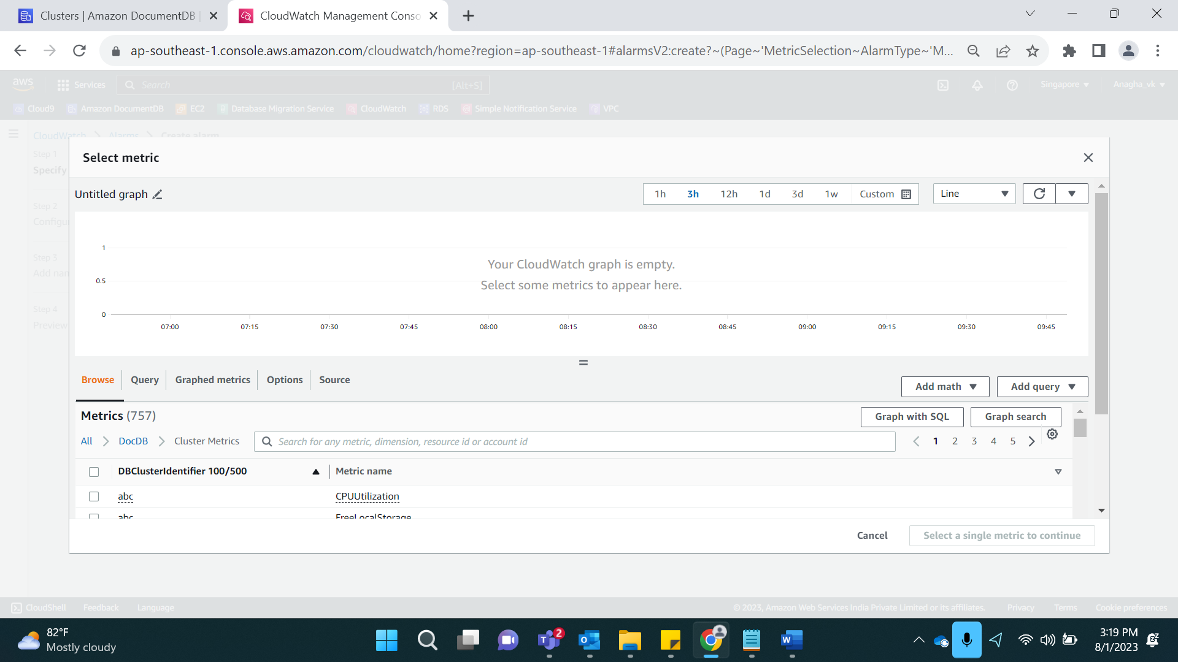

Select CPU Utilization

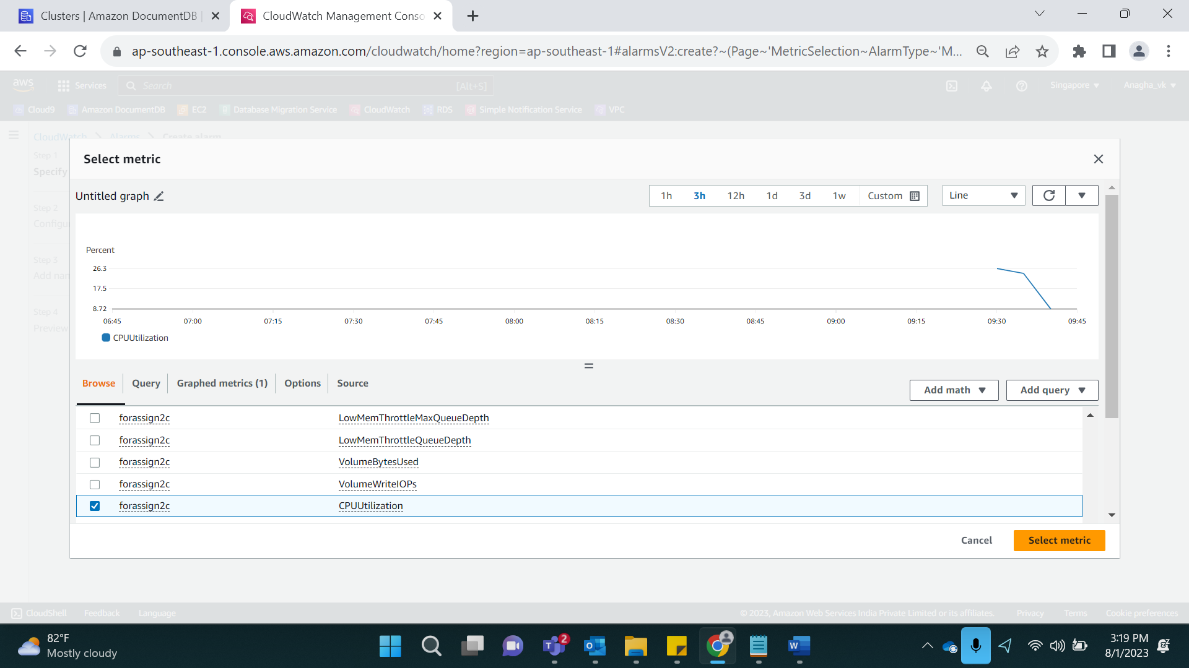

Click on Select Metric

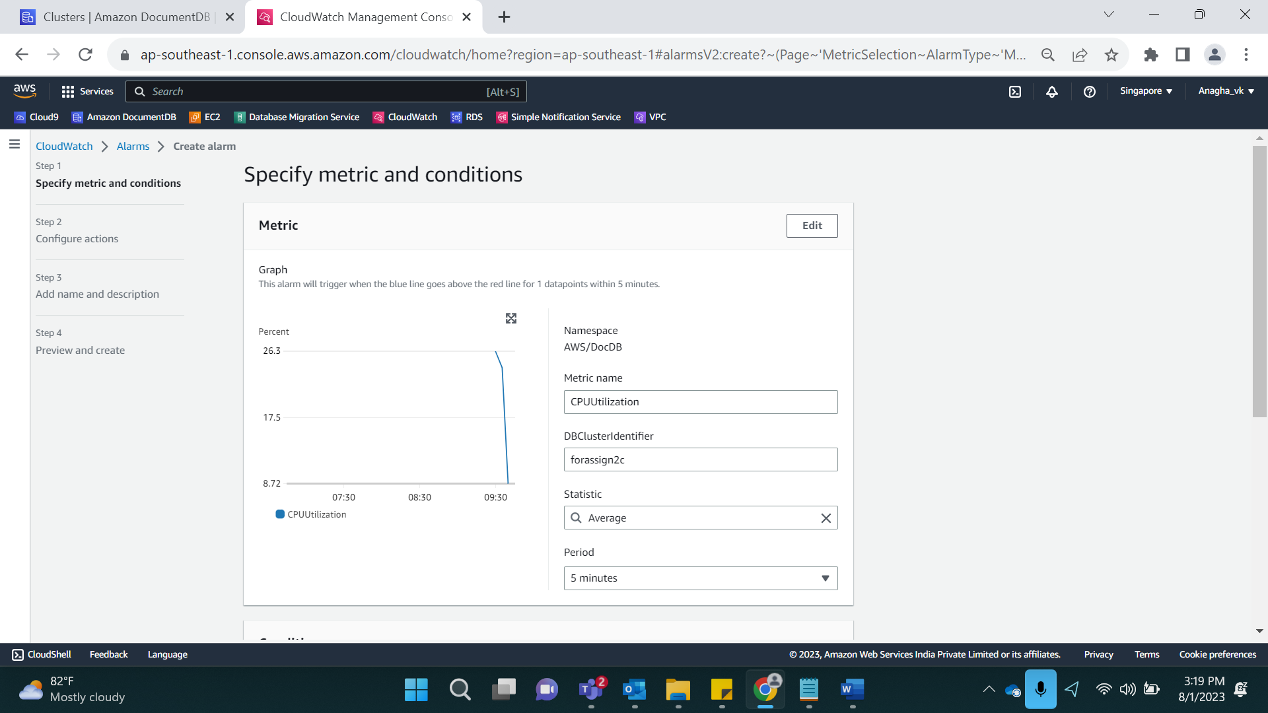

Enter Value as 80:

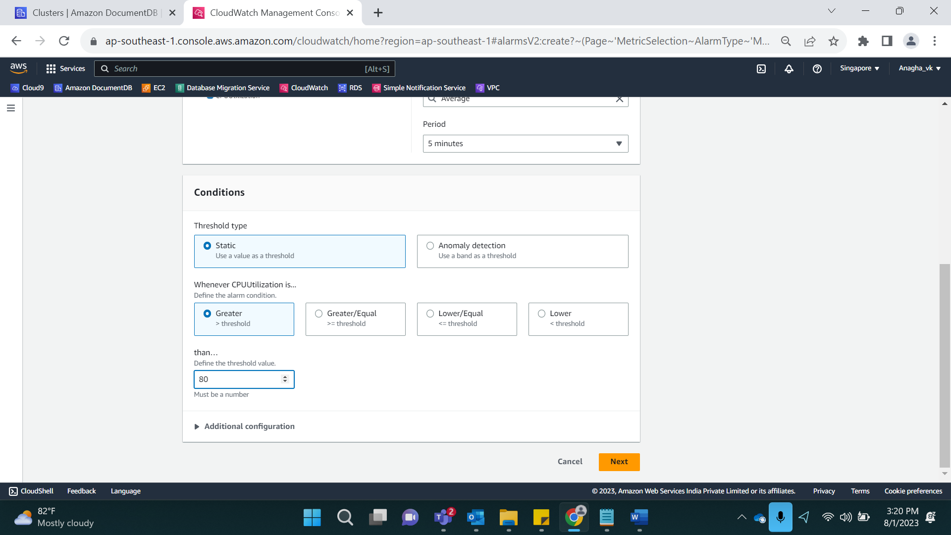

Select existing SNS topic As Assign5

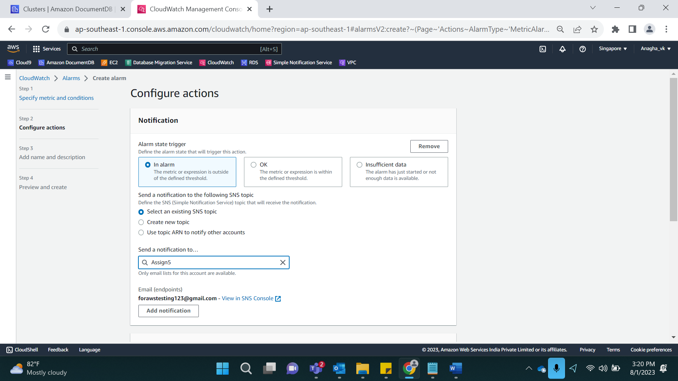

Enter Msg title and description

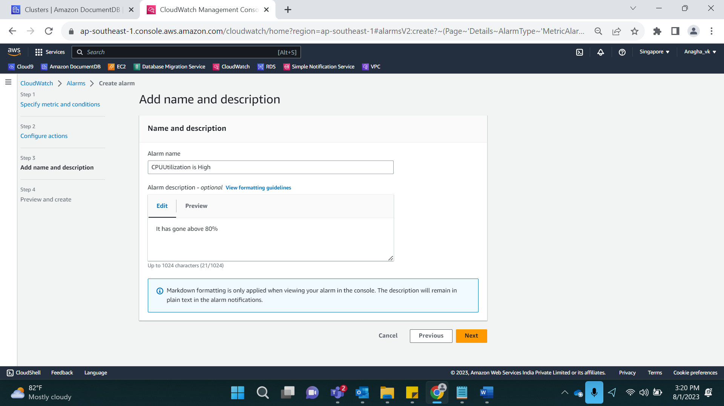

Click on Next. It will show preview.

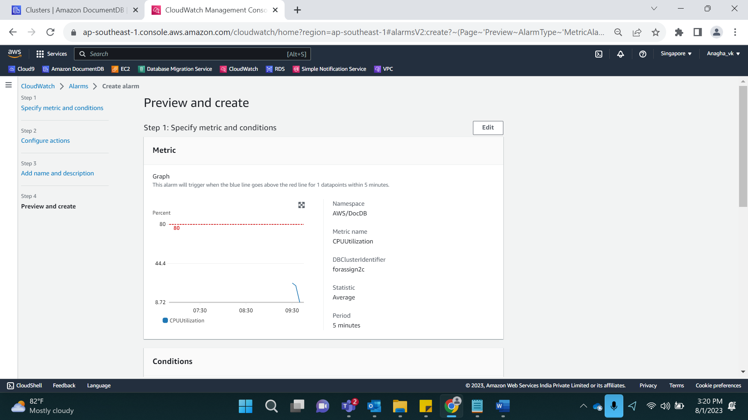

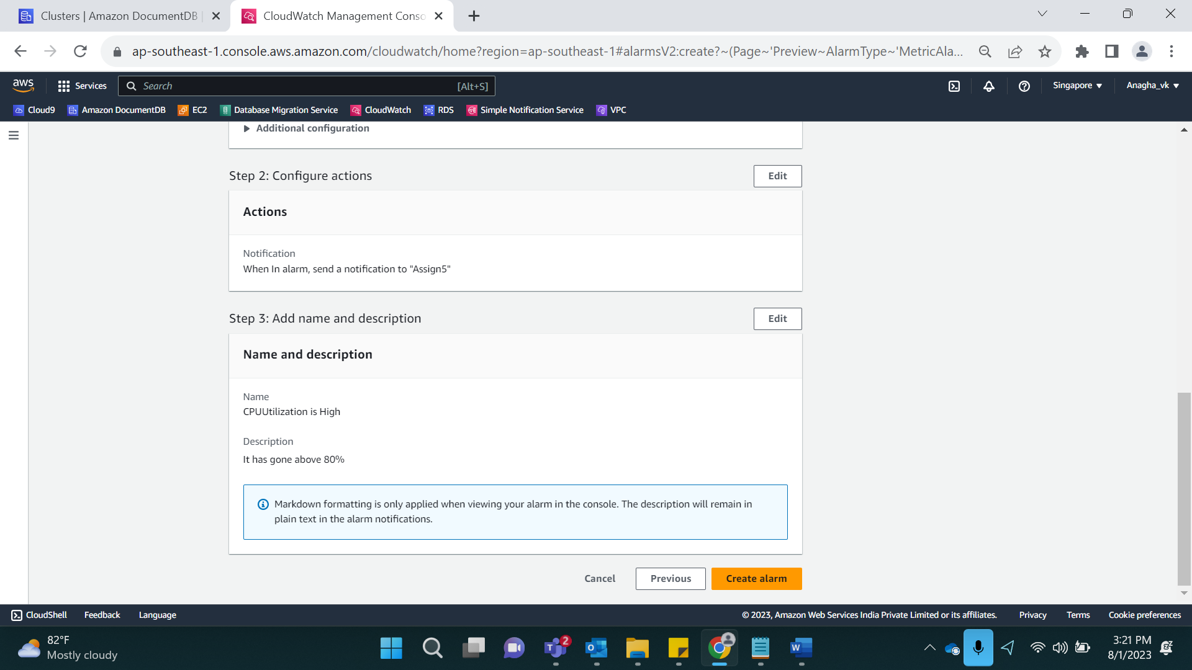

Click on Create Alarm.

Result:

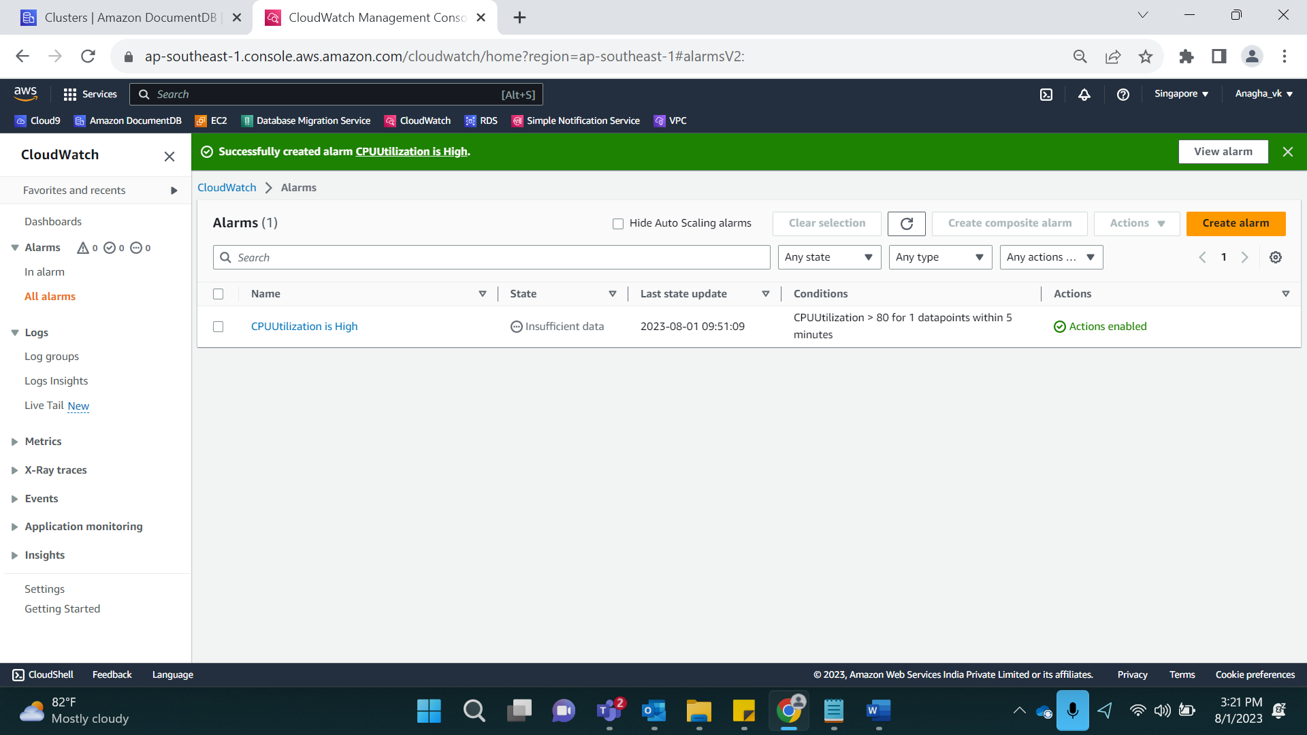

Adding few more Alarms:

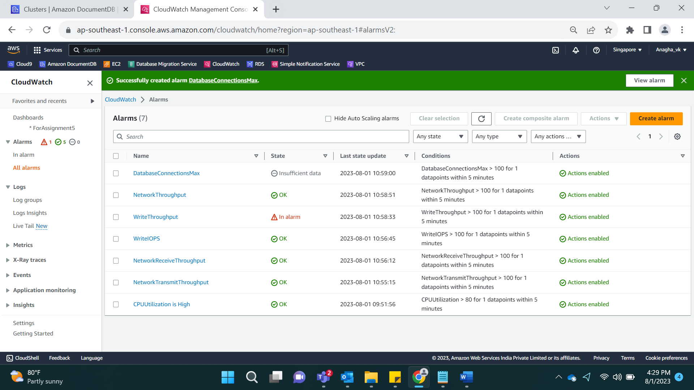

In Alarm State:

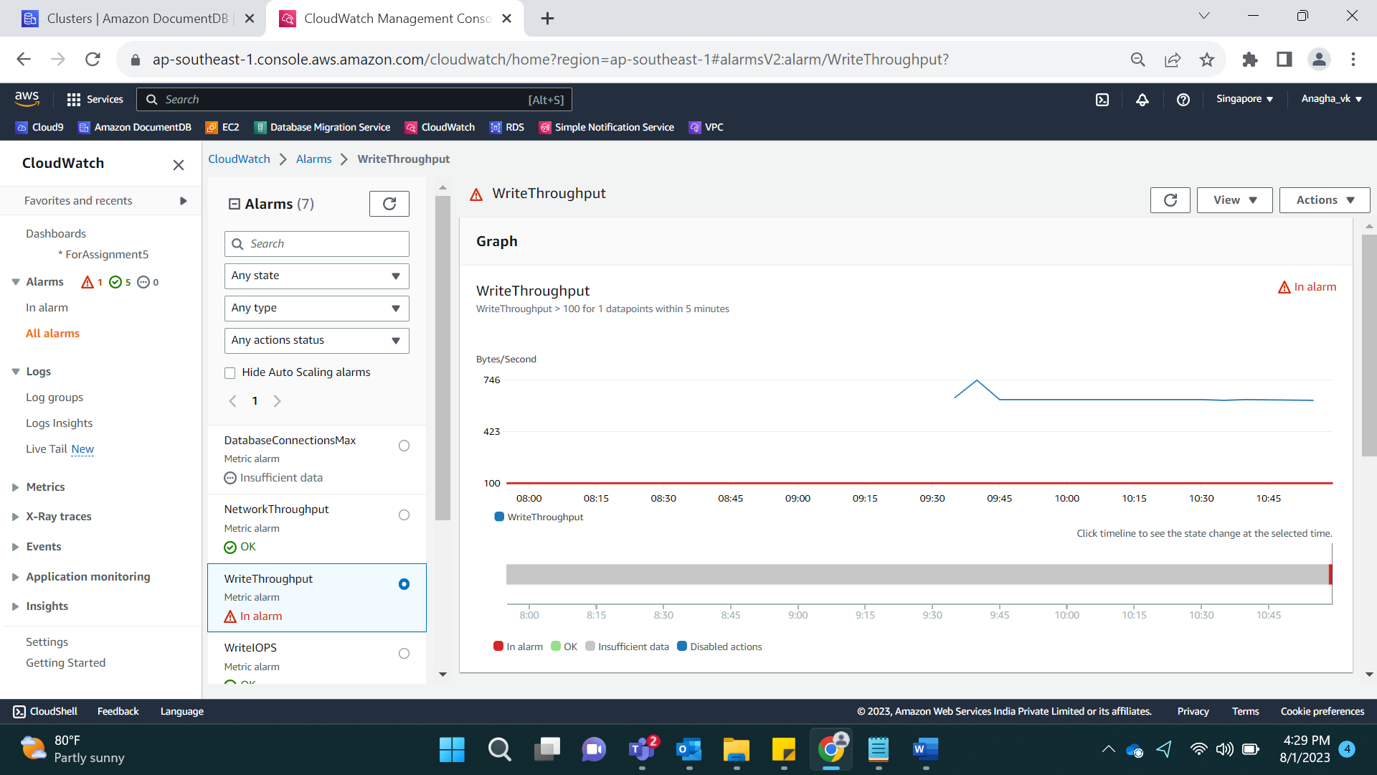

When in Alarm:

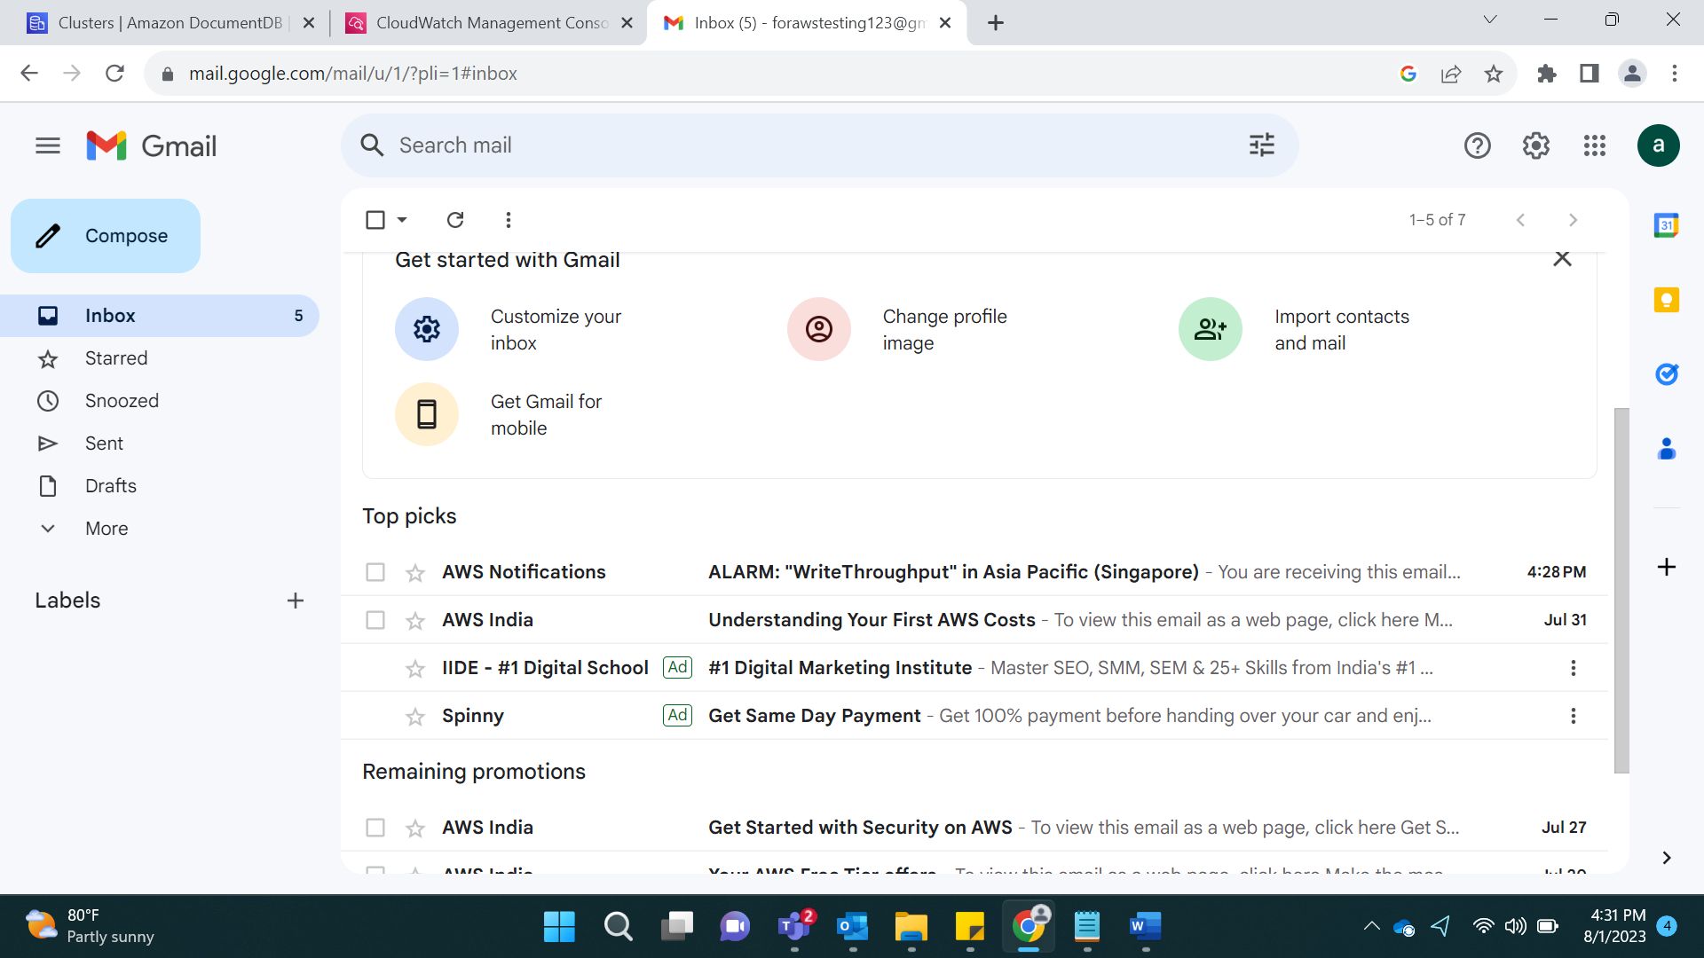

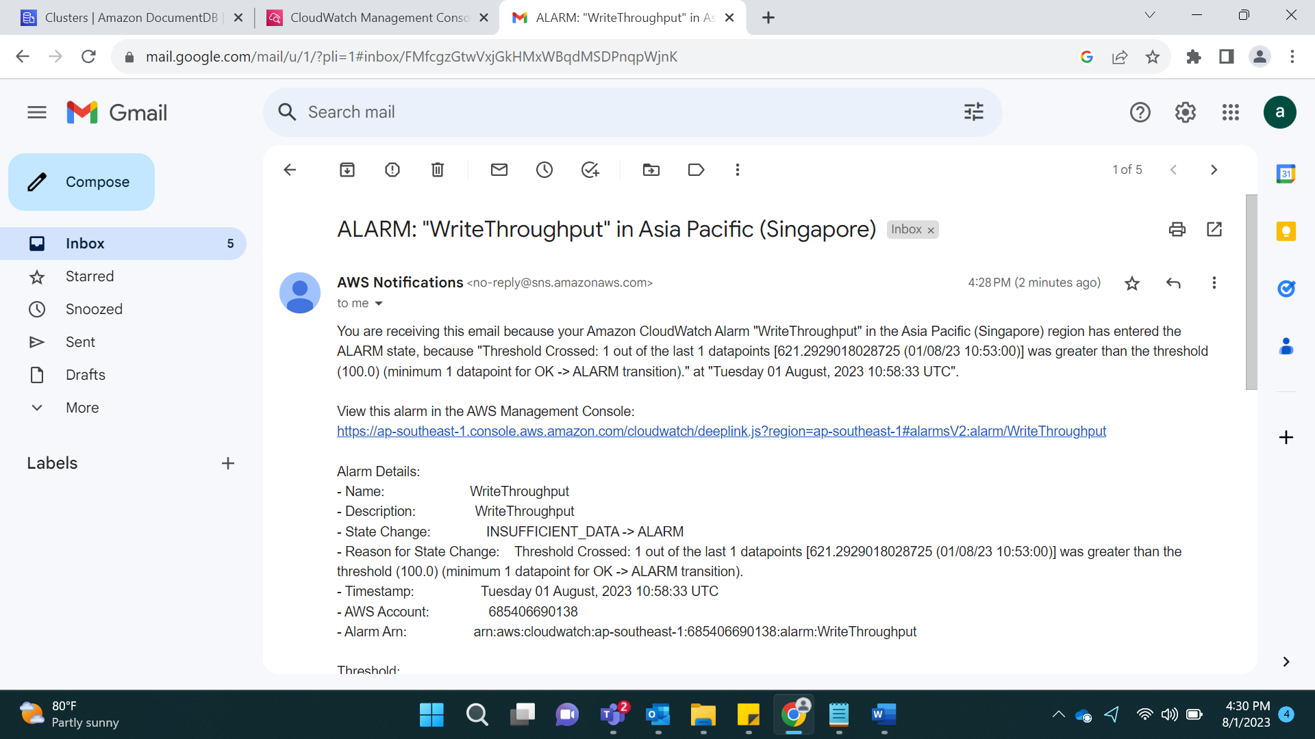

Create A Dashboard:

Go To CloudWatch and Create a Dashboard. Enter a name:

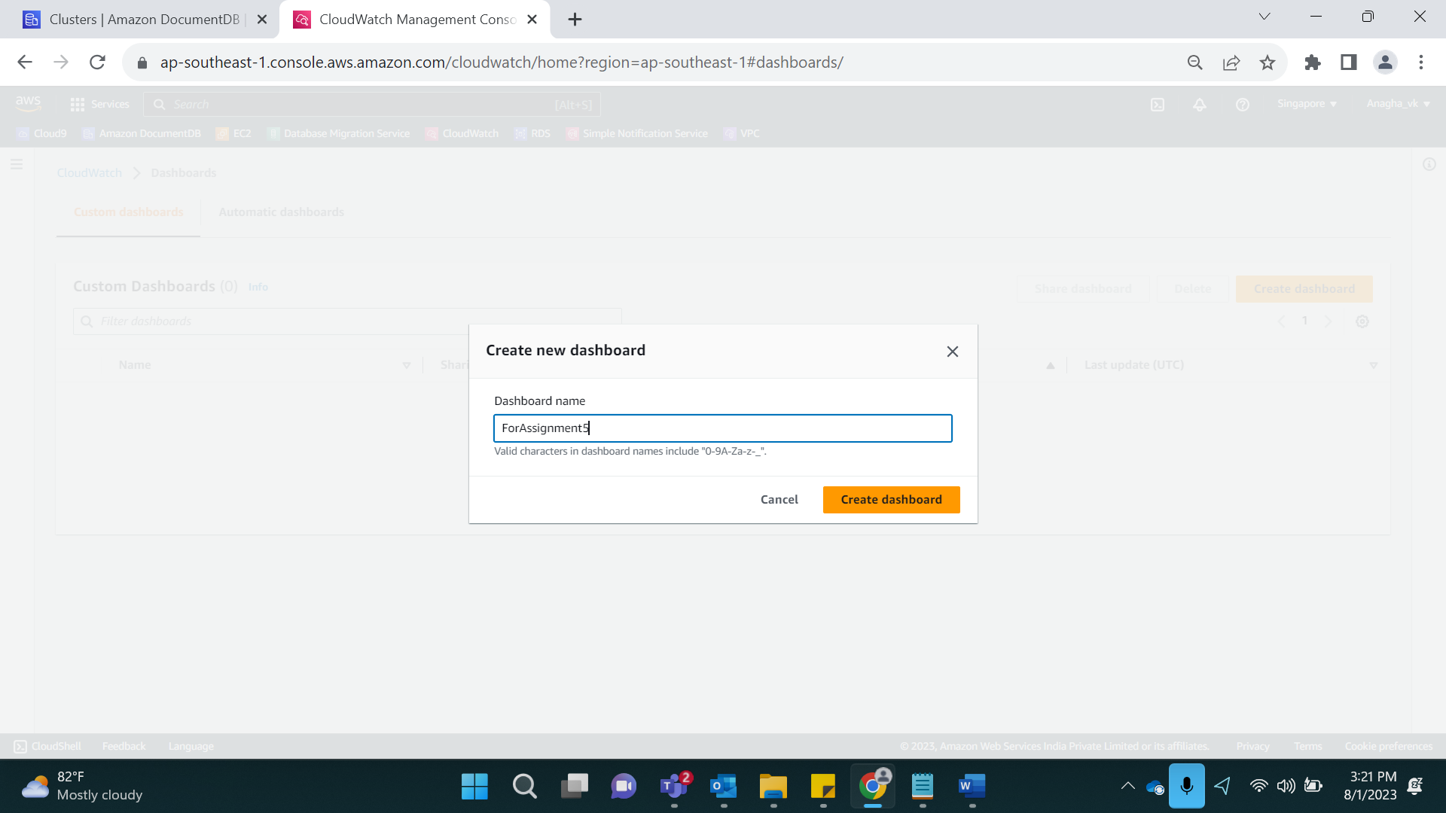

Select which graph we want. I selected Line Graph and Metrics

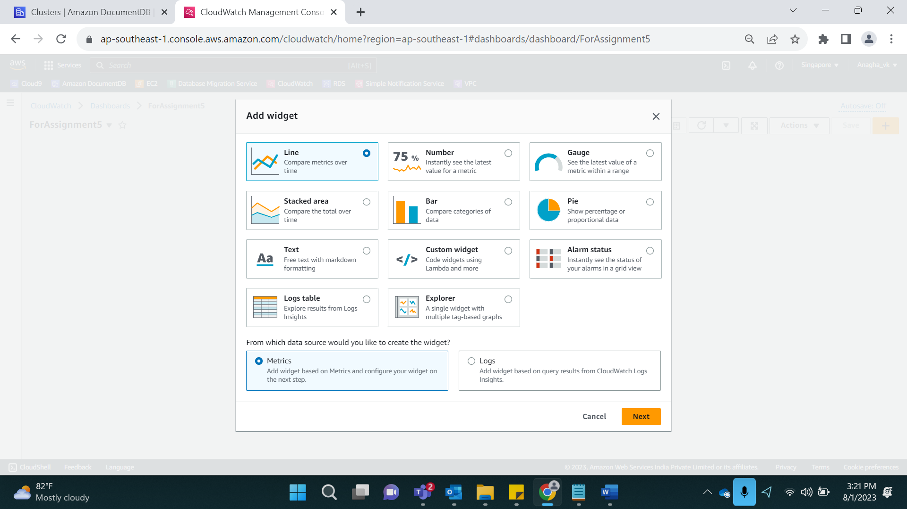

Select For which cluster we need graph and parameter

Eg. Forassign2c->CPUUtilization

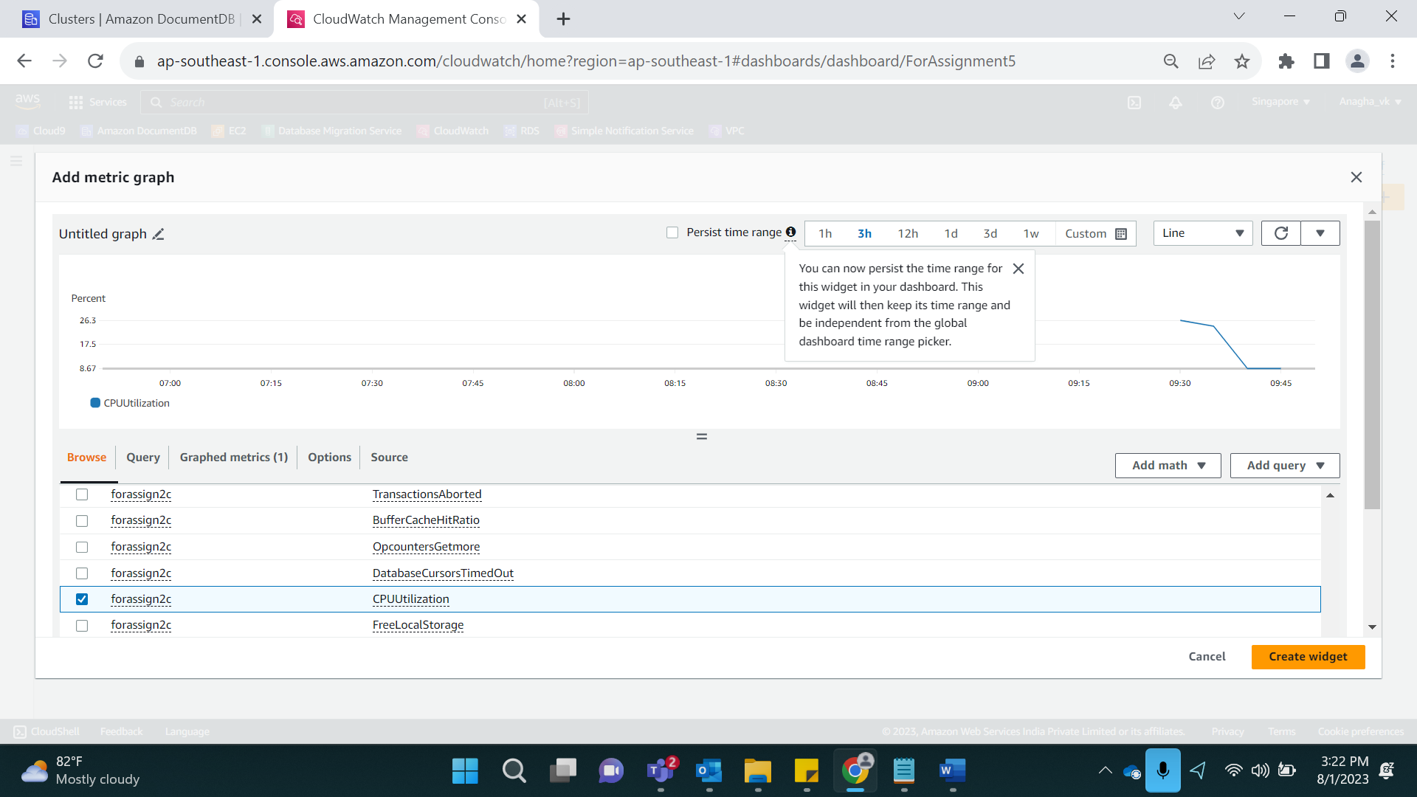

Result:

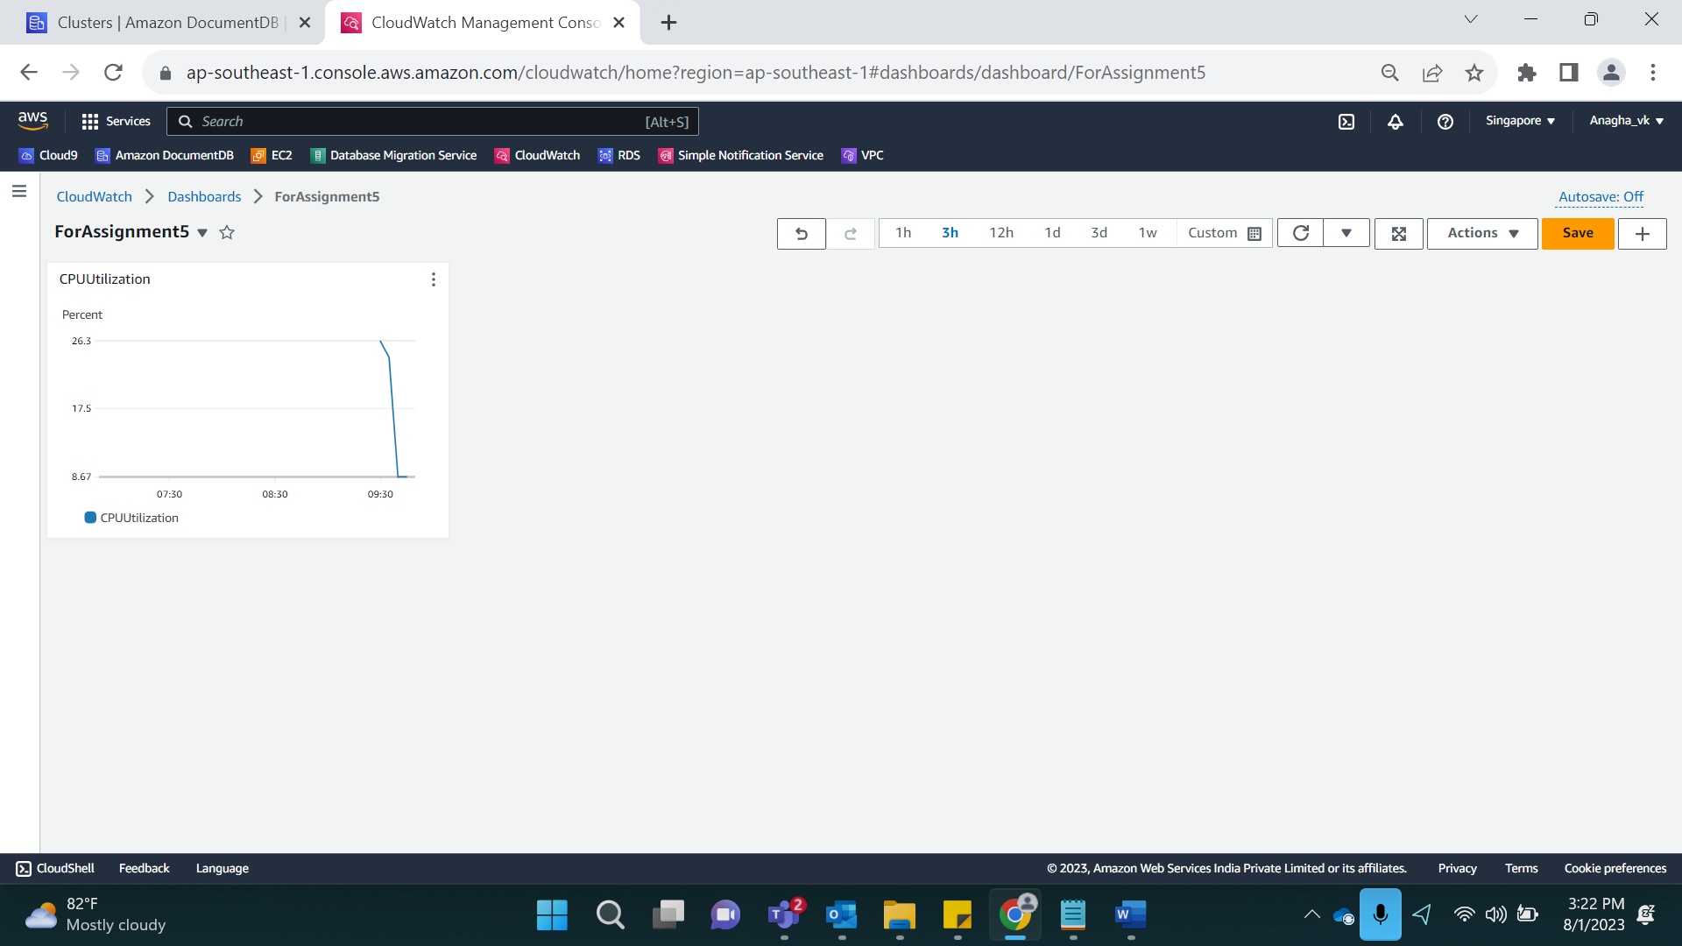

Adding a few more important Metrics:

NetworkThroughput

NetworkReciveThroughput

NetworkTransmitThroughput

WriteThroughput

WriteIOPS

DatabaseConnectionsMax

